CERTIFICATE

This is to certify that the Project Report submitted by RUDRA HITESHBHAI TANK (22SE02CE048) to the P P SAVANI UNIVERSITY for the partial fulfilment of the subject credit requirements is a bonafied work carried out by the student.

This is to further certify that I have been supervising the Major/Minor Project of RUDRA HITESHBHAI TANK (22SE02CE048).

The contents of this report, in full or in parts, have not been submitted to any other Institute or University for award of any degree, diploma or titles.

Sign of Faculty Mentor :

Name of Faculty Mentor : Ms. Hemangni Mehta

Date:

ACKNOWLEDGEMENT

This report would not have been possible without my teachers who were always there when I needed them the most. I take this chance to acknowledge them and extend my sincere gratitude for helping me make this Report a possible.

I wish to thank my faculty mentor Ms. Hemangni Mehta, Assistant Professor, School of Engineering. It has been an honor to learn under their mentorship.

As my mentor, she has constantly motivated me to remain focused on achieving my goal. Their observations and guidance helped me to establish the overall direction of the report and to move forward with learning in depth. Their vital support at each juncture, which culminated in successful completion of my project work. I express my sincere gratitude to them for constant support during the project work.

I am also thankful to faculty members of the department for constant support and guidance.

I am thankful to Dean, School of Engineering for his initiative of imparting Project during tenure of your study making us learn new things and to help us in expanding our horizons.

Name of Student : RUDRA HITESHBHAI TANK
Enrollment No : 22SE02CE048

ABSTRACT

The increasing complexity of managing examination seating arrangements in educational institutions has made manual methods inefficient, error-prone, and time-consuming. This project presents a Smart Exam Seating Allocator, a web-based system designed to automate the generation of seating plans using structured classroom and student data. Developed using Django, Python, Pandas, and OpenPyXL, the system processes uploaded Excel files and produces optimized seating arrangements in a standardized format.
The system incorporates rule-based allocation logic to ensure fairness and compliance with institutional constraints. Key features include maintaining a two-seat buffer in each classroom, limiting the number of branches per room, and preventing the placement of students from the same department but different academic years together. The allocation process prioritizes larger student groups and dynamically adjusts to available capacity.
The application generates a professionally formatted Excel report containing room-wise seating details, branch distribution, and summary statistics. The user interface is simple and efficient, enabling users to upload files and download results in a single step. This solution significantly reduces administrative workload, minimizes errors, and improves the efficiency and transparency of examination management processes.

Table of Contents
CERTIFICATE i
ACKNOWLEDGEMENT ii
ABSTRACT iii
1. INTRODUCTION 1
2. SYSTEM ANALYSIS 2
2.a Identification of Need 2
2.b Preliminary Investigation 2
2.c Feasibility Study 3
2.d Project Planning 4
2.e Project Scheduling 5
2.f Software Requirement Specification (SRS) 7
2.g Software Engineering Paradigm Applied 9
2.h Data Models & Diagrams 10
3. SYSTEM DESIGN 13
3.a MODULARISATION DETAILS 13
3.b DATA INTEGRITY AND CONSTRAINTS 17
3.c USER INTERFACE DESIGN 20
3.d TEST CASES 23
4. CODING 26
4.a COMPLETE PROJECT CODING 26
4.b COMMENTS AND DESCRIPTION OF CODE SEGMENTS 28
5. STANDARDIZATION OF CODING 32
5.a Code Efficiency and Error Handling 32
5.b Parameter Calling and Passing 32
5.c Validation Checks 33
6. TESTING AND VALIDATION 34
6.a Testing Techniques & Strategies 34
6.b Testing Plan 35
6.c Test Reports 36
6.d Debugging & Code Improvements 37
7. Reports (Sample Layouts) 38
7.a Seating Allocation Summary (Sample Layout): 38
7.b Branch-wise Allocation Report (Sample Layout): 39
7.c Quick Summary(Right panel): 40
7.d Overall Output: 41
7.e Error: 41
8. Future Scope and Enhancements 42
8.a Integration with Institutional ERP Systems 42
8.b AI-Driven Predictive Allocation 42
8.c Automated Invigilator Assignment 42
8.d Real-Time Dashboard & Analytics 42
8.e Mobile-App Integration 42
8.f Advanced Security & Compliance 42
8.g Multilingual Support 42
8.h Cloud Deployment 43
9. SYSTEM SECURITY MEASURES 44
9.a Data Security 44
9.b File Validation and Input Security 44
9.c Error Handling and Exception Management 45
9.d Access Control (Current & Future Scope) 45
9.e Protection Against Malicious Inputs 45
10. COST ESTIMATION OF THE PROJECT 47
10.a Estimation Method 47
10.b Effort Distribution 47
10.c Cost Calculation 48
10.d Tool Cost 48
10.e Maintenance Cost 49
11. Bibliography 50
12. Appendices 51
13. Glossary 52

LIST OF FIGURES

Sr no. | Figure | Pg no.
 | Figure 1 Gantt Chart | 14
 | Figure 2.1: DFD Level 0 – Smart Exam Seating Allocator | 16
 | Figure 3 E R Diagram | 18
 | Figure 4(a) Landing page  Figure 4(b) Sign-in page  Figure 4(c) Dashboard  Figure 4(d) Consultation Chat  Figure 4(e) History Page  Figure 4(f) Summary Page  Figure 4(g) Booking Appointment  Figure 4(h) Confirm Booking  Figure 4(i) Confirm Email | 19

List of tables

1. INTRODUCTION
Conducting examinations for multiple departments and semesters within an institution involves complex planning and coordination. A major logistical responsibility is preparing accurate and fair seating arrangements that prevent malpractices, ensure even distribution, and comply with academic separation rules such as avoiding seating students of the same department but different academic years together.
Traditionally, examination seating plans are prepared manually using spreadsheets or handwritten charts, which leads to delays, inconsistencies, and frequent re-working during busy academic periods. As universities grow in scale, manual methods become insufficient.
The Smart Exam Seating Allocator is designed to completely automate the generation of examination seating charts based on uploaded class and student data. Using Django for backend processing and Pandas/OpenPyXL for Excel manipulation, the system produces institution-standard formatted reports in seconds while enforcing complex business logic such as:
- Keeping 2 seats empty in each classroom
- Allowing maximum 2 branches per room
- Preventing seating collisions between same-department different-year branches
- Distributing students fairly and optimally
The system is scalable, accurate, user-friendly, and adaptable to any academic institution with minimal customization.
OBJECTIVES:
The primary objectives of the Smart Exam Seating Allocator are:
- Automate seating arrangement creation and eliminate manual spreadsheet errors.
- Ensure fair and rule-based seating distribution with constraints such as:
  - Two-seat buffer per classroom
  - Avoiding same-department year conflicts
  - Limiting branch mixing
- Generate professional-format Excel output compatible with official examination reports.
- Simplify administrative workload for examination controllers and class coordinators.
- Enable dynamic scaling, allowing unlimited classrooms and student groups.
- Provide a simple and intuitive user interface for uploading inputs and downloading results.
- Store no sensitive data, ensuring secure and stateless processing.
- Deliver results instantly, reducing exam preparation time significantly.

2. SYSTEM ANALYSIS

2.a Identification of Need
Universities conduct examinations for thousands of students across diverse departments such as IT, CE, CSE, Mechanical, etc. Seating must be organized in a standardized way to maintain discipline, minimize malpractices, and comply with academic separation rules.
Manual preparation leads to:
- Overlapping allocations
- Errors in student counts
- Improper mix of branches
- Non-adherence to seating constraints
- Time-consuming corrections
There is a clear need for a smart, automated, rule-based seating generator that eliminates human error and speeds up the process.

2.b Preliminary Investigation
A comprehensive preliminary investigation was conducted to understand the current examination seating workflow and identify gaps that impact efficiency, accuracy, and compliance. The assessment revealed that most institutions rely heavily on manual data handling, with examination staff preparing seating plans through Excel sheets or handwritten layouts. While workable at small scale, this approach breaks down rapidly as the number of departments, classroom combinations, and student batches increases.
The analysis highlighted that no automated or rule-driven distribution mechanism was in place. Staff typically enforce seating constraints manually, often overlooking critical academic separation rules—such as avoiding same-department, different-year combinations—during high-pressure exam periods. These oversights not only increase the likelihood of malpractice but also trigger last-minute revisions.
Formatting also emerged as a major pain point. Although Excel sheets serve as the backbone of the seating plan, the final output requires substantial manual editing to meet institutional reporting standards. Adjusting column widths, applying borders, setting headers, and refining layout consumes significant time and introduces preventable inconsistencies.
Frequent changes in classroom availability or student count further complicate the process. Even small updates often require a full reseating exercise, resulting in repetitive administrative effort and delayed exam preparation cycles.
From this investigation, several clear opportunities for improvement emerged:
✔ Automation is essential to reduce the repetitive workload and eliminate human error.
✔ A dynamic allocation algorithm is required to apply constraints intelligently and adapt to changing inputs.
✔ Excel output must be institution-ready, both in structure and presentation.
✔ A web-based interface would streamline access, eliminate installation overhead, and increase usability for non-technical staff.
Overall, the preliminary investigation established a strong case for developing an automated, scalable, and rule-aware seating allocation system.

2.c Feasibility Study
To validate whether the proposed Smart Exam Seating Allocator could be executed reliably within existing constraints, a feasibility assessment was conducted across three dimensions: technical, operational, and economic.
1. Technical Feasibility
The solution leverages a modern yet accessible technology stack. Django offers a robust backend framework capable of handling data processing, rules execution, and file generation with speed and reliability. Pandas and OpenPyXL deliver powerful Excel manipulation capabilities, allowing the system to read, transform, and export data seamlessly. On the frontend, standard HTML and CSS ensure a clean, intuitive interface without requiring advanced or high-cost tooling.
Because the system requires no proprietary software, advanced hardware, or complex configurations, it runs efficiently on any standard desktop or laptop used within the institution. The architecture is flexible, extensible, and easy to maintain.
Conclusion: The project is technically feasible and can be implemented using widely supported open-source technologies.
2. Operational Feasibility
The operational workflow is designed to be exceptionally simple for examination staff. Users only need to upload two Excel files—classroom details and student lists—and initiate the process through a single action. The system processes the data instantly and provides the final seating arrangement for download, formatted to match institutional standards.
This eliminates the need for training, reduces dependency on technical expertise, and minimizes operational overhead. The tool integrates seamlessly into existing examination processes without disrupting established norms.
Conclusion: The system is operationally feasible, highly usable, and requires minimal intervention.

3. Economic Feasibility
The entire solution is built using open-source components, ensuring that the development, deployment, and maintenance costs remain negligible. There are no licensing fees or recurring operational expenses. Institutions can deploy the tool locally without investing in servers or commercial software.
The automation significantly reduces manual effort, lowers the risk of costly human errors, and saves substantial staff hours—indirectly improving workforce productivity.
Conclusion: The project is economically feasible, cost-effective, and delivers long-term value.

2.d Project Planning
The development was structured into well-defined phases to ensure clarity, accountability, and steady progress. Each phase contributed directly to the functional robustness and operational reliability of the system.
- Requirement Collection
Gathering detailed inputs from examination staff, identifying business rules, data formats, and operational constraints.
- UI Design
Designing a minimal and intuitive interface focused on simplicity, accessibility, and clean user flow.
- Core Allocation Algorithm Design
Engineering the logic responsible for distributing students optimally while enforcing rules like branch mixing limits, department-year separation, and seat buffers.
- Django Project Setup
Establishing the backend structure, models, APIs, and file-handling mechanisms.
- Excel Formatting Logic
Defining and implementing the formatting standards required for institution-ready Excel outputs.
- Integration of Upload–Processing–Download Pipeline
Connecting the frontend, backend, and Excel engine into a seamless, end-to-end workflow.
- Testing with Sample Inputs
Running multiple real-world test cases to validate accuracy, rule enforcement, and formatting quality.
- Optimization and Cleanup
Refining performance, ensuring scalability, and removing redundant code or processes.
- Documentation and Deployment
Preparing user guides, system documentation, and deploying the final build for institutional use.

2.e Project Scheduling

1. PERT Chart
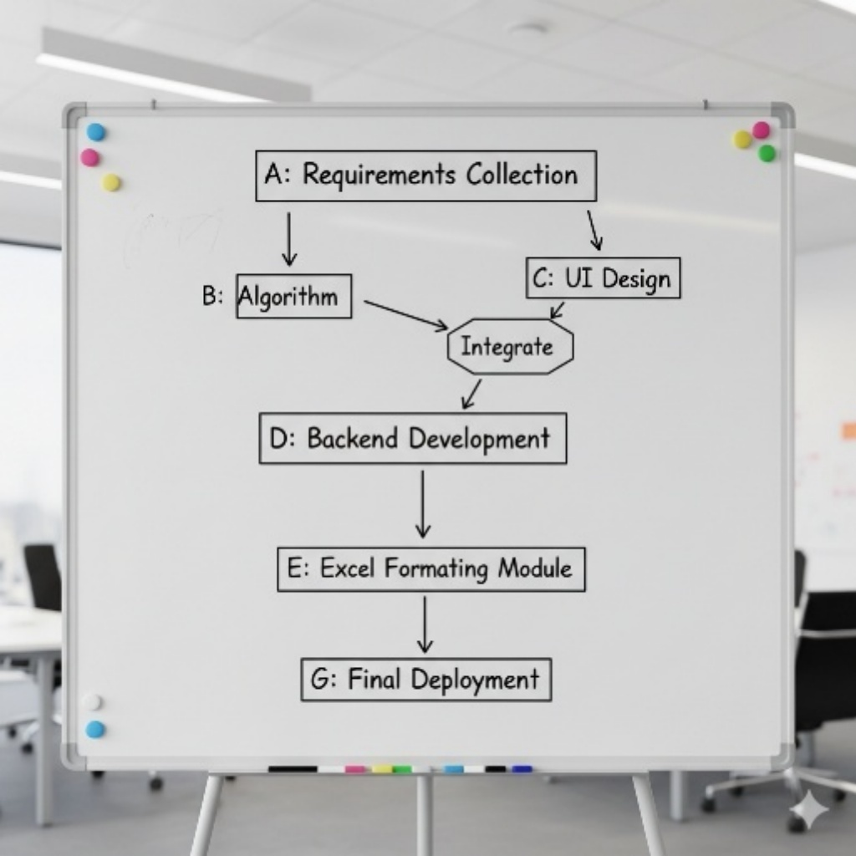
Figure 2.6: PERT Chart for Project Scheduling

2. Gantt Chart

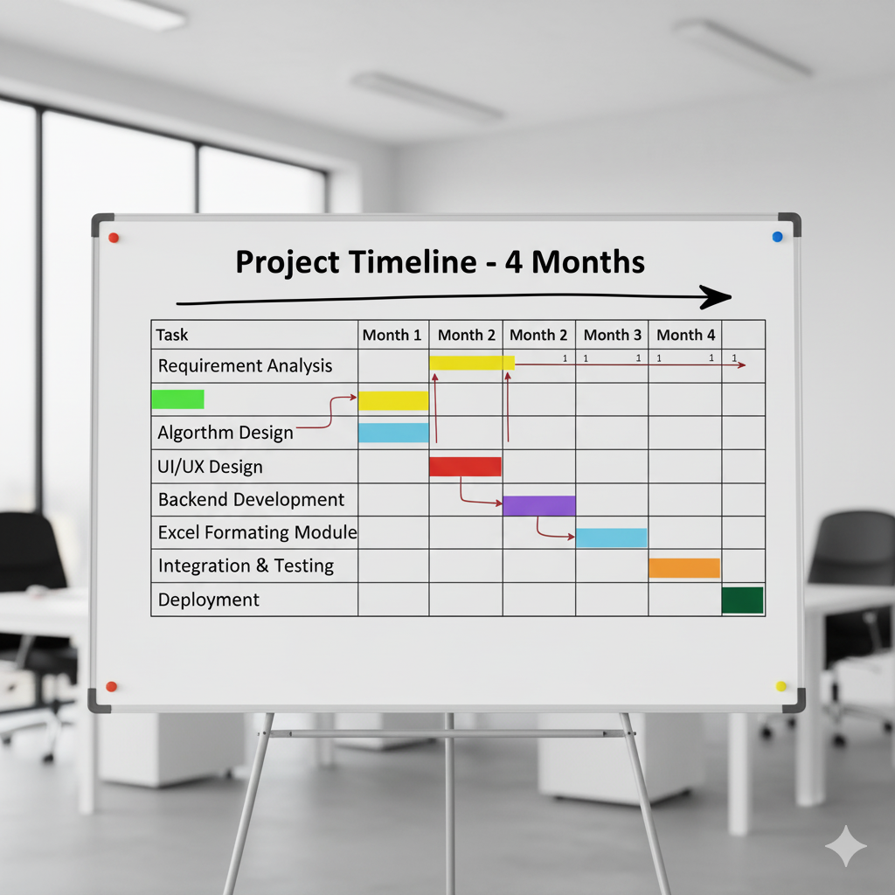
Figure 2.7: Gantt Chart for Project Timeline

2.f Software Requirement Specification (SRS)

1. Functional Requirements
The Smart Exam Seating Allocator is designed to deliver end-to-end automation for generating examination seating plans. The following functional requirements define the core capabilities of the system:
- Classroom Capacity File Upload
The system must allow examination staff to upload an Excel file containing classroom names, capacities, and available seating layouts. This file serves as the foundational dataset for allocation.
- Student Branch File Upload
Users must be able to upload the student dataset, including branch, year, roll numbers, and other relevant academic details. This input is processed to enforce department- and year-based separation rules.
- Input Format Validation
The application should validate both uploaded Excel files to ensure correct structure, required column names, and clean data. Any inconsistencies or missing fields must trigger clear error messages.
- Rule-Based Allocation Processing
The system must apply predefined business rules—such as branch mixing limits, avoidance of department/year conflicts, two-seat buffer logic, and balanced distribution—before generating the seating chart.
- Automated Excel Output Generation
The application must produce institution-standard formatted Excel sheets that include room-wise seating distribution, student details, headers, gridlines, and consistent formatting.
- One-Click Download
Once processing is complete, the system should automatically provide the final Excel file for download without requiring additional steps from the user.
2. Non-Functional Requirements
To ensure consistent performance and high operational value, the system must adhere to the following non-functional requirements:
- High Accuracy
The allocation algorithm should produce error-free seating plans that strictly comply with academic rules and room capacities.
- Fast Performance
The system must generate the seating arrangement within seconds, even for large student batches and numerous classrooms.
- Reliability
The platform should operate consistently under repeated use, ensuring dependable processing with no unexpected failures.
- Maintainability
The codebase must be modular and readable, enabling easy future upgrades, rule modifications, or integration with new institutional workflows.
- Usability
The interface must be simple, intuitive, and accessible to non-technical staff, ensuring a smooth user experience.
- Security (No Data Storage)
The application must not store any uploaded student or classroom data. All processing should be conducted in real time, ensuring privacy and safeguarding sensitive academic information.

3. User Requirements
Understanding the needs of examination staff and coordinators, the system must meet the following user-oriented requirements:
- Simple and Clean UI
Users should be able to navigate the interface effortlessly, with minimal steps and clear instructions.
- No Login or Credentials Required
The system must remain unlockable and instantly accessible without user authentication, reducing friction and speeding up usage.
- Offline and Online Compatibility
The tool must function locally on a computer without internet access while also supporting deployment on local networks or web servers.
4. System Requirements
The successful execution of the platform depends on the following software and environment prerequisites:
- Python 3.8 or Above
Required for running the backend logic and supporting all associated libraries.
- Django 4.x or Higher
Used as the primary backend framework for handling file uploads, processing workflows, and output generation.
- Pandas and OpenPyXL Libraries
Essential for processing, manipulating, and exporting Excel files with accurate formatting.
- Web Browser
Any modern browser (Chrome, Edge, Firefox, etc.) is sufficient for accessing the user interface and downloading output files.

2.g Software Engineering Paradigm Applied
To ensure structured development, controlled progress, and continuous enhancement, the Incremental Model was selected as the software engineering paradigm for the Smart Exam Seating Allocator. This model was chosen because it aligns effectively with the project’s technical complexity, phased functional requirements, and need for rapid iteration.
The Incremental Model allowed the system to be developed in well-defined segments, enabling early delivery of core capabilities while subsequent features were added in controlled increments. By building the solution layer by layer, it maintained flexibility, reduced development risk, and ensured high-quality output at every stage.

Reasons for Selecting the Incremental Model
- Rapid Development Cycles
The model supports delivering functional components quickly and efficiently. For this project, the allocation engine—the heart of the system—was developed and validated early, enabling faster feedback loops and early performance assessment. This helped stakeholders visualize results sooner and make informed refinements.
- Early Construction of the Core Allocation Logic
Since the allocation rules, conflict handling, and distribution algorithms form the backbone of the system, the incremental approach made it possible to build and test this core logic in the initial iteration. Once this central module proved stable, subsequent increments such as UI, Excel formatting, and validation layers were systematically added.
- Smooth Integration of Excel Layout and User Interface
Features like file uploads, Excel formatting standards, and the download workflow were implemented in later increments. This staged approach ensured that the frontend and formatting logic were built upon a fully functional and reliable backend engine, minimizing rework and compatibility issues.
- Continuous Testing and Refinement
The incremental model inherently promotes testing at the end of every cycle. Each new component was validated independently and then tested in combination with existing modules. This continuous evaluation allowed quick identification of issues, adherence to requirements, and refinement of rules or formatting as needed. It also ensured that each version of the system was stable, usable, and ready for practical deployment.
Outcome of Using the Incremental Model
By applying the Incremental Model, the development process remained efficient, modular, and predictable. The system evolved through multiple working versions, reducing risk and enabling proactive improvements. This approach directly contributed to building a robust, scalable, and user-friendly Smart Exam Seating Allocator capable of handling real-world institutional demands.

2.h Data Models & Diagrams
Below diagrams are provided in ASCII format.
- DFD Level 0
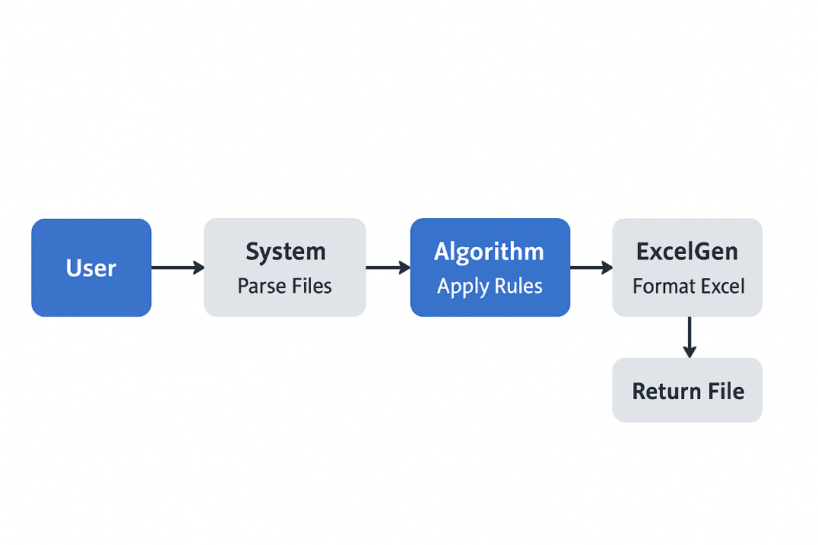
Figure 2.1: DFD Level 0 – Smart Exam Seating Allocator

- DFD Level 1

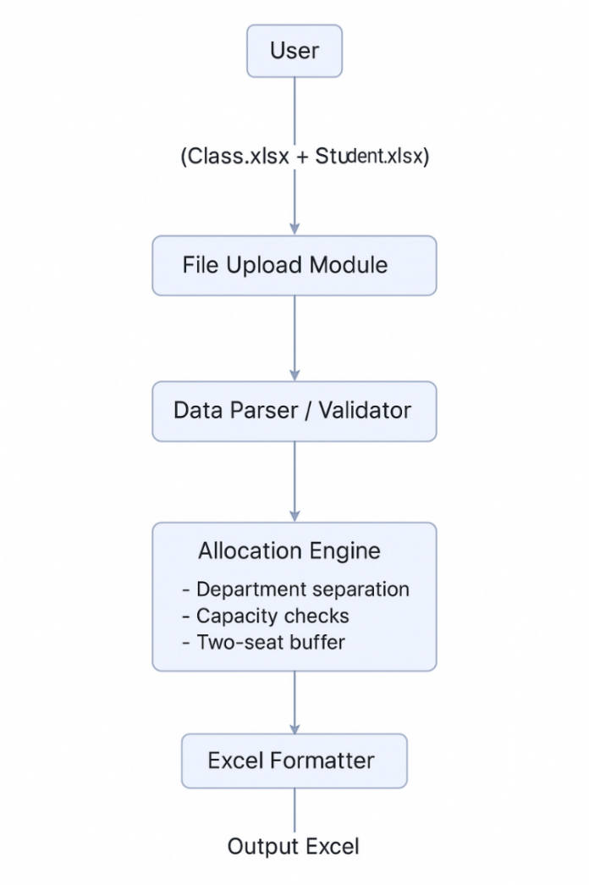
Figure 2.2: DFD Level 1 – Detailed Data Flow of Seating System

- Use Case Diagram (ASCII)

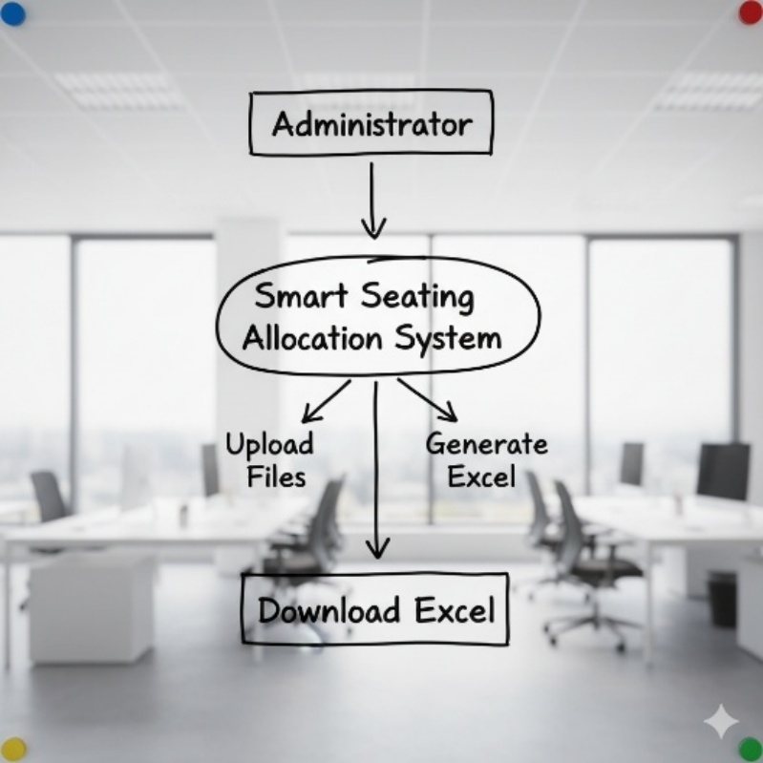
Figure 2.3: Use Case Diagram of Seating Allocation System
- Class Diagram
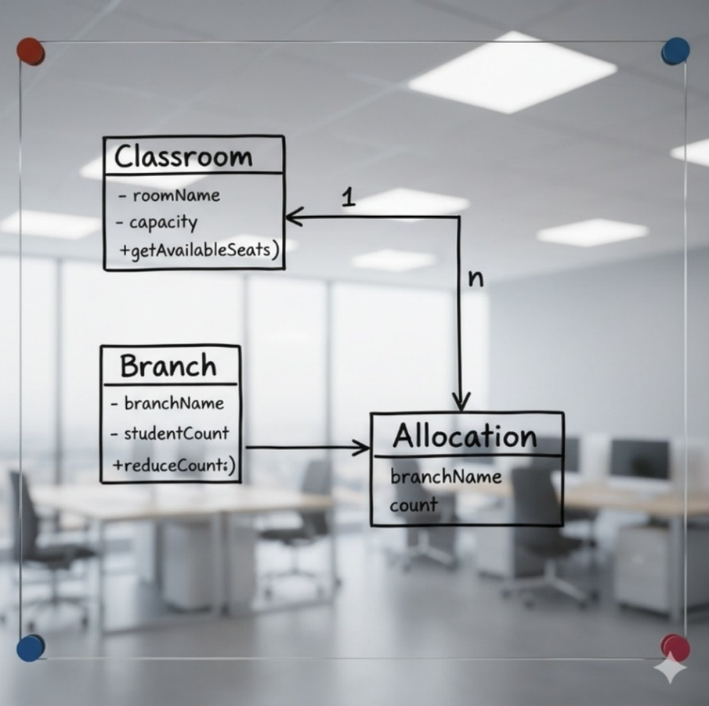

Figure 2.4: Class Diagram of System Modules

- Activity Diagram

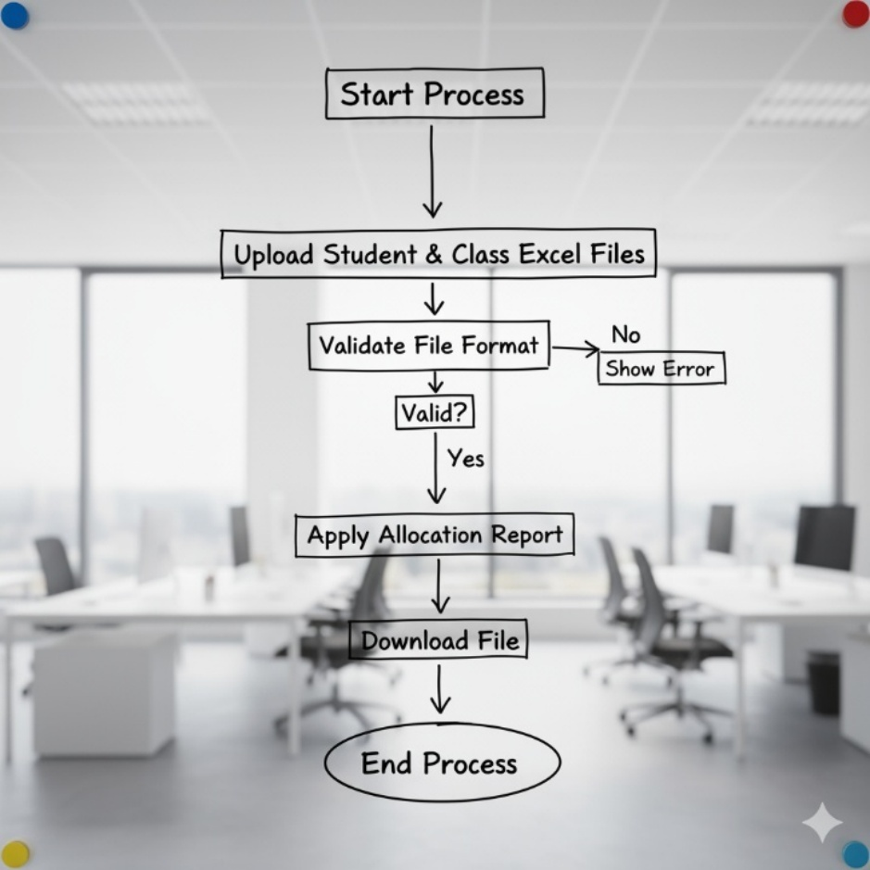
Figure 2.5: Activity Diagram for Seating Allocation Process

3. SYSTEM DESIGN

3.a MODULARISATION DETAILS
The Smart Exam Seating Allocator is engineered using a modular software design, ensuring clarity, maintainability, and scalable performance. Each module performs a distinct responsibility within the overall workflow, creating a seamless pipeline from file upload to final output generation. The following sections provide a detailed explanation of each module as documented for the project report.
1. File Upload Module
The File Upload Module serves as the system’s entry point. It manages the intake of the two primary datasets required for processing:
- Classroom capacity file (Class.xlsx)
- Student branch file (Student.xlsx)
Key Responsibilities
- Accepting user input: Handles uploads of both Excel files through the web interface.
- File type validation: Allows only .xlsx or .xls formats; rejects unsupported or unsafe file types.
- Integrity checks: Detects empty, corrupted, or unreadable files and returns clear error feedback.
- Schema validation: Ensures that required columns such as RoomID, Capacity, Branch, and Year are present.
- Error handling: Provides user-friendly alerts for missing data, incorrect formats, or inconsistent input structures.
Importance
By enforcing clean and correct input data, this module ensures downstream components operate on reliable datasets, preventing cascading failures later in the process.
2. Data Preprocessing Module
This module transforms raw uploaded data into standardized, structured, and validated datasets. It prepares both classroom and student information for accurate and conflict-free allocation.
Key Responsibilities
- Data cleaning: Removes empty rows, trims extra spaces, normalizes branch names, and resolves formatting inconsistencies.
- Column standardization: Maps variant column headings to system-defined names for consistency.
- Type conversion: Converts capacity and numeric fields into integer formats.
- Sanity checks: Detects mismatched or inconsistent values such as negative capacities, duplicate roll numbers, or invalid year values.
- Branch aggregation: Groups students by branch and year for allocation.
Importance
The preprocessing module significantly enhances reliability by ensuring all datasets follow a uniform structure before reaching the allocation engine.
3. Allocation Module
This is the operational core of the system where rules, constraints, and allocation strategies are executed. It automates seating arrangements while strictly adhering to institutional guidelines.
Key Responsibilities
- Applying business rules:
  - Maintains a 2-seat buffer per classroom.
  - Prevents placing same-department, different-year students in the same hall.
  - Limits each room to maximum two branches under normal conditions.
  - Allows a third branch only when necessary based on availability constraints.
- Optimized seat distribution:
  - Sorts branches by descending student count for efficiency.
  - Allocates students room-by-room using a greedy optimized algorithm.
- Fair allocation logic:
  - Ensures balanced student distribution across all rooms.
  - Tracks remaining unseated students and optimizes placement iteratively.
- Error and conflict handling:
  - Detects and resolves allocation bottlenecks.
  - Reports capacity shortages, unavoidable conflicts, or required rule relaxations.
Importance
This module ensures fairness, compliance, and operational efficiency, making manual seating preparation obsolete.

4. Excel Report Generator Module
Once allocation is finalized, this module prepares a professional-grade Excel output that matches institutional formatting standards.
Key Responsibilities
- Header formatting: Generates four merged header rows containing exam details, date, and class information.
- Seating layout creation:
  - Builds structured tables representing each classroom allocation.
  - Places branches and roll numbers in organized seat order.
- Branch summary creation: Generates a right-side table summarizing student distribution by branch, year, and room usage.
- Excel styling using OpenPyXL:
  - Applies borders, cell alignment, font styling, and bold headers.
  - Adjusts column widths for optimal readability.
  - Ensures the final workbook is clean, printable, and institution-ready.
Importance
It produces a standardized and polished report that can be directly used by examination departments without further editing.

5. Download Response Module
This module handles the final step—delivering the generated Excel file to the user via the web interface.
Key Responsibilities
- File packaging: Converts the Excel workbook into an in-memory stream for download.
- HTTP response generation: Sends the file as an attachment using Django’s HttpResponse.
- Safe and efficient transfer:
  - Prevents caching to avoid unintended sharing of data.
Ensures the file downloads instantly upon successful processing.
Importance
It provides a seamless end-to-end user experience by enabling one-click download of the finalized seating plan.

Benefits of Modular Design
The modular architecture of the Smart Exam Seating Allocator provides several operational and technical advantages, ensuring long-term stability, scalability, and ease of management. The key benefits are outlined below:
1. Reusability
- Each module is independent and can be reused across similar academic automation systems.
- Components such as the File Upload Module or the Allocation Engine can be integrated into other projects with minimal modification.
- Enhancements to one module do not require redesigning the entire system.
2. Maintainability
- Clear separation of responsibilities ensures clean code organization.
- Updates to allocation rules, UI components, or Excel formatting can be made without affecting other modules.
- Documentation and module boundaries simplify onboarding for new developers.
3. Easy Debugging
- Errors can be traced to specific modules, greatly reducing debugging time.
- Each module can be unit-tested individually.
- Fault isolation prevents system-wide failures and improves reliability.
4. Scalability
- Individual modules can scale independently as data size grows.
- The Allocation Engine can be optimized or parallelized without impacting the upload or Excel generation components.
- New features such as PDF export or seat-level visual mapping can be added by introducing new modules.
5. Flexibility & Extensibility
- New business rules (e.g., 3-seat buffer, department clustering, multi-floor hall mapping) can be added easily.
- UI upgrades or backend system changes can be executed independently.
- Supports rapid iteration and incremental feature development.
6. Security
- Sensitive data is processed in isolated modules, minimizing exposure.
- No long-term data storage ensures compliance with privacy guidelines.
- Controlled data flow prevents accidental leakage between components.
7. Reliability
- Structured module interactions reduce chances of cascading failures.
- Validated inputs, isolated processing, and controlled outputs improve overall operational stability.
- System behaves predictably even when scaling to hundreds of rooms and thousands of students.
8. Better Testing & Audit
- Module-wise testing improves test coverage and early bug detection.
- Allocation logs, preprocessing summaries, and error reports provide strong auditing capability.
- Easier to track changes and ensure traceability of results.

3.b DATA INTEGRITY AND CONSTRAINTS

Although the Smart Exam Seating Allocator does not employ a traditional database or persistent storage, it ensures high data integrity through strict validation rules and multi-layered constraints. Since all processing occurs directly in memory during a single execution cycle, the accuracy, consistency, and reliability of the output depend heavily on strong controls applied at the input, allocation, and output stages. The system incorporates the following integrity mechanisms to maintain correctness throughout the process.
1. Input Constraints
To ensure that only valid and usable data enters the allocation pipeline, the system enforces a comprehensive set of input-level checks.
a. Mandatory File Submission
The algorithm requires both Excel files—Classroom Capacity and Student Branch Details—to be uploaded before processing can begin.
Incomplete submissions are immediately rejected to prevent partial or inconsistent computation.
b. Column Validation
Each file must include all required columns, such as:
- Room Name / Room ID
- Capacity
- Branch
- Year
- Student Count (if applicable)
If any expected column is missing, mislabelled, or incorrectly formatted, the system halts and provides an error message.
c. Data Type Enforcement
Fields such as capacity, student count, and year must contain numeric values, ensuring predictable computational behavior.
The system automatically flags:
- Strings in numeric columns
- Negative values
- Blank or null entries

d. Branch Name Validation
Branch names must follow alphanumeric formatting, preventing corrupt or malformed identifiers such as special characters, merged cells, or incomplete entries.
This ensures consistency during sorting, grouping, and allocation.
Purpose of Input Constraints
These controls guarantee that the system begins with clean, structured, and validated data—minimizing downstream errors and eliminating ambiguity during allocation.
2. Allocation Constraints
The core allocation engine maintains integrity by enforcing predefined academic and operational rules. These constraints ensure fairness, avoid conflicts, and guarantee that the seating layout adheres to institutional standards.
a. Mandatory 2-Seat Buffer
Each classroom must maintain a two-seat empty buffer as an anti-malpractice measure.
This rule is applied to every room regardless of capacity.
b. Department–Year Separation Rules
The system strictly rejects combinations where:
- Students from the same department but different academic years are placed in the same room.
This preserves academic integrity and aligns with institutional examination policies.
c. Branch Mixing Controls
To avoid overcrowding and cross-group interference:
- A maximum of two branches per classroom is permitted under normal circumstances.
- A third branch may be accommodated only if the room has more than 5 unallocated seats after initial placement.
This conditional relaxation ensures the system remains flexible while respecting institutional boundaries.

d. Non-Negative Branch Sizes
During allocation:
- Student counts must never become negative.
- Each deduction is validated before proceeding.
This prevents computational anomalies and maintains correct tracking of remaining students.
e. Capacity Compliance
The system ensures that:
- Total allocated students never exceed the capacity (after buffer deduction).
- Overflows are detected immediately, preventing invalid or unsafe room assignments.
Purpose of Allocation Constraints
These rules ensure a fair, conflict-free, and logically sound seating distribution that mimics the quality and discipline of manually prepared exam seating charts—while drastically improving speed and accuracy.
3. Output Constraints
To maintain professional presentation and compatibility with official examination formats, the system enforces detailed output integrity checks during Excel creation.
a. Compliance with Official Formatting Standards
The generated Excel file mirrors the structure expected by examination departments, including:
- Four-level merged headers
- Standardized table structures
- Branch summaries
- Balanced text alignment
This ensures the report is immediately usable without manual reformatting.
b. Proper Row and Column Alignment
Every cell within the seating layout and branch summary is:
- Correctly positioned
- Uniformly bordered
- Vertically and horizontally aligned
This eliminates inconsistencies such as misaligned data, uneven table widths, or fragmented layouts.
c. Formula-Driven Totals
All totals—such as:
- Total students allocated
- Branch-wise distribution
- Room capacity usage
are generated using Excel formulas instead of static values.
This allows:
- Real-time recalculation if edits are made
- Transparent auditing
- Improved reliability
These measures ensure that the final output is accurate, readable, professionally formatted, and officially compliant, with no risk of inadvertent manipulation or misreporting.

3.c USER INTERFACE DESIGN
The User Interface (UI) of the Smart Exam Seating Allocator has been carefully designed to ensure simplicity, clarity, and ease of use for examination administrators and academic staff. Since the system performs specialized processing with minimal user interaction, the UI adopts a streamlined and intuitive layout that minimizes cognitive load and eliminates unnecessary complexity. The interface supports fast task execution while maintaining a clean, professional appearance aligned with institutional expectations.

Design Principles Followed
The UI is guided by established design principles to ensure usability, accessibility, and functional efficiency. The key design principles applied are:
1. Minimalistic Layout
The interface intentionally avoids excessive elements, decorative visuals, and distracting components. Users interact only with two file-upload inputs and a single action button, making the workflow straightforward and user-friendly.
- No sidebars, pop-ups, toolbars, or redundant options
- Only essential components displayed
- Flat design structure to reduce clutter
This minimalism ensures rapid comprehension and eliminates the possibility of user confusion during busy examination periods.

2. Center-Aligned Structure
All interactive components are centrally aligned within the viewport. This placement enhances accessibility by ensuring that:
- The user’s focus remains on primary actions
- Elements are reachable with minimal cursor movement
- The UI remains visually balanced across different screen sizes
Center alignment also contributes to a structured and professional aesthetic.
3. Clean Typography
The system uses simple, readable fonts with proper spacing and consistent sizing. Typography plays a crucial role in ensuring clear communication, especially in high-pressure administrative workflows.
- Sans-serif fonts for modern readability
- Strategic use of bold text for section headers
- Adequate spacing between elements for readability
This approach supports accessibility for users with varying visual comfort levels.
4. No Visual Clutter
The design avoids unnecessary icons, graphics, or animations. Only core components are displayed, ensuring that the user’s cognitive effort remains focused on the task at hand.
- No background patterns
- Neutral color palette
- Logical separation between input fields
This reduces distractions and speeds up data submission.
5. High-Contrast Action Button
The “Generate Seating Excel” button uses a high-contrast color to ensure strong visibility and encourage confident user interaction.
- Clear contrast with background
- Large clickable area
- Distinct appearance marking it as the primary action
This ensures quick user recognition and reduces operational errors.

UI Wireframe:
The following wireframe represents the structural layout of the user interface, illustrating how the components are arranged on the screen:
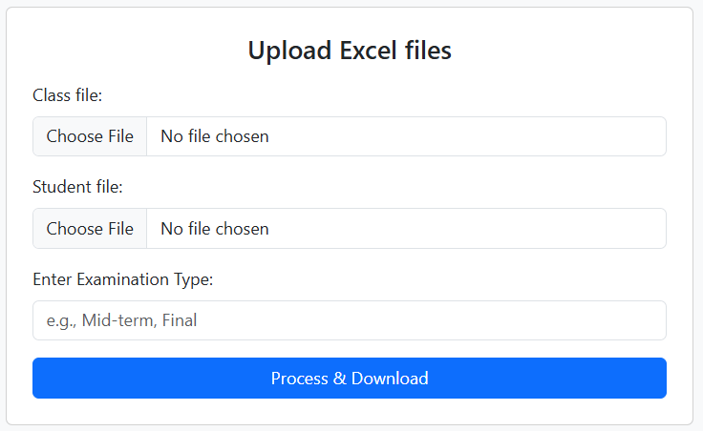
Figure 3.1: User Interface Wireframe for File Upload System

Wireframe Description
- Header Section: Displays the system name in a large, bold typeface for immediate recognition.
- Upload Inputs: Two file selectors are provided—one for classroom capacity data and one for student branch data. They are placed sequentially for logical flow.
- Spacing: Adequate vertical spacing ensures readability and easy navigation.
- Primary Action Button: The “Generate Seating Excel” button is placed centrally beneath the upload section for quick access.
- Layout Style: Rectangular container with symmetrical margins for visual balance.

3.d TEST CASES

Unit Test Cases:

A comprehensive suite of unit tests was designed to ensure the reliability, accuracy, and functional correctness of the Smart Exam Seating Allocation System. These test cases validate each isolated module—file handling, allocation logic, and Excel report generation—before they are integrated into the full workflow. The goal is to guarantee predictable system behavior under valid, borderline, and erroneous conditions.

1. File Upload Module Test Cases
These tests verify whether the system handles user-uploaded files correctly, validates formats, and enforces mandatory inputs.

Test Case | Input | Expected Output
TC1: Upload both files | Classroom Excel + Student Excel | System accepts both files and proceeds to parsing.
TC2: Only classroom file uploaded | 1 file | Error message displayed: “Both input files are required.”
TC3: Incorrect file format | PDF, JPG, or corrupted file | Error displayed: “Invalid file format. Only Excel files are supported.”
Table 3.1: File Upload Module Test Cases

2. Allocation Logic Test Cases
These tests confirm the accuracy and robustness of the core allocation engine, which executes the seating rules and fairness constraints.

Scenario | Input | Expected Output
Two branches fit within capacity | Room: 48 seats  Branch A: IT5 = 30 students  Branch B: CE5 = 20 students | Balanced allocation: IT5 → 23 seats, CE5 → 23 seats ensuring equitable distribution.
Same department but different years | Branches: IT5 and IT7 | System must not allocate both branches to the same room as per “No mixing of same-dept different-year rule.”
Overflow handling | Students exceed classroom capacity | Extra students must be tracked and stored in the “Remaining Students” pool for allocation in next available room.
Table 3.2: Allocation Logic Test Scenarios

3. Excel Generation Test Cases
These tests validate the correctness and formatting integrity of the Excel output generated using the OpenPyXL library.

Test Activity | Expected Result
Header merge validation | Cells A1:N4 must be merged to create the official report header.
Check if Column O is empty | Column O must remain unused as per formatting specification.
Right-side summary table alignment | Branch summary table must be perfectly aligned and bordered.
Formula validation | Totals row and aggregate formulas (SUM, COUNT) must compute correctly.
Table 3.3: Excel Generation Validation Cases

SYSTEM TEST CASES:
After individual components passed unit testing, holistic system tests were executed to validate full end-to-end performance and stability.
1. Full System Integration Test
This test verifies whether all modules—File Upload → Preprocessing → Allocation Engine → Excel Generator → Download Module—operate cohesively without manual intervention.
Expected Outcomes:
- User uploads two Excel files.
- System preprocesses and validates data.
- Allocation engine executes seating rules and generates room-wise distribution.
- Excel file is created using official formatting.
- File automatically downloads through HTTP response.
- No intermediate pages or manual steps required.
- Output must strictly adhere to allocation rules and layout specifications.
This confirms the seamless functioning of the entire workflow and ensures a smooth and efficient user experience. It guarantees that no data corruption, rule violation, or formatting inconsistencies occur during transitions between internal modules.

2. Stress Testing
To evaluate scalability, the system was tested under heavy load conditions.
Stress Conditions:
- 100+ classrooms
- 200+ branches
- Random seat capacities
- Varying student volumes
Expected Result:
- System should complete allocation and Excel generation in under 5 seconds.
- No crashes, memory leaks, or performance degradation.
- Output must remain accurate and rule-compliant even under extreme volumes.
Stress testing ensures the system remains efficient and reliable during peak examination seasons where large datasets are common. This demonstrates operational resilience and validates the underlying allocation algorithm's optimization strategy.
System must generate output in < 5 seconds.

4. CODING

4.a COMPLETE PROJECT CODING

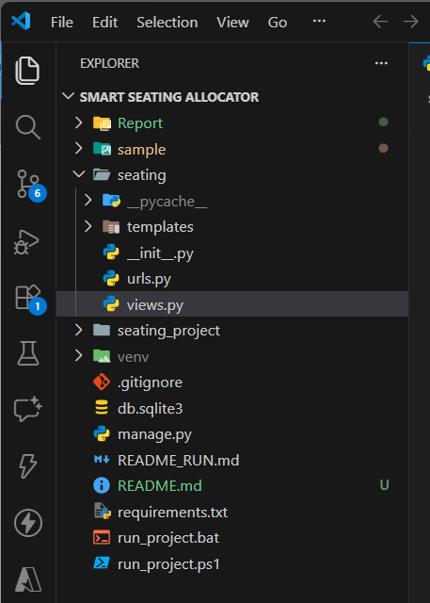

1. Department Extraction Utility:
A helper routine standardizes branch names and derives their department prefix. This enables conflict-free seating by ensuring branches from the same department are not placed in the same room.
2. Greedy Allocation Engine:
A custom algorithm drives the full seating strategy. Key business rules include:
- Strict two-seat safety buffer in every classroom.
- Dual-branch allocation model with a balanced 50/50 distribution in the first phase.
- Department-based conflict detection to prevent adjacent placement of related branches.
- Priority allocation where high-volume branches are mapped first.
- Block-based distribution supporting up to four blocks per room.
- Controlled mop-up phase, ensuring third and fourth blocks only populate when remaining capacity crosses a defined threshold.
- Dynamic utilization tracking to continuously update branch-level seat allocations.
The engine outputs a structured dataset including room-wise block details, total occupancy, and a summary of unallocated students.
3. Excel Report Generator:
A dedicated module prepares a professionally formatted Excel workbook that includes:
- Merged title section (A1:N4) with institutional headers.
- Primary seating table (left grid) featuring capacity, block assignments, counts, and computed totals using Excel formulas.
- Branch summary table (right grid) highlighting original strength, remaining students, and room distribution.
- Automated column sizing, intelligent merged-cell handling, and visual formatting enhancements (alignment, borders, shading).
- Robust styling framework ensuring readability and an audit-ready layout.
The generator returns a fully constructed .xlsx workbook ready for download.
4. File Upload Processing (Django View):
The main web endpoint orchestrates the end-to-end workflow:
- Validates presence of both classroom and student Excel files.
- Performs type-safe data extraction using pandas and openpyxl.
- Applies sanitization steps like header removal, null-row filtering, and forced numeric conversion.
- Executes the allocation engine and passes results to the report generator.
- Streams the resulting workbook back to the user as a downloadable Excel file.
- Includes full exception management to provide resilient, user-friendly error handling.
5. Overall System Flow:
- Upload → Classrooms & Student Excel sheets
- Parse & Standardize → Cleaned DataFrames
- Greedy Allocation → Seat distribution logic
- Excel Render → Styled report generation
- Serve Output → Final downloadable seating plan

4.b COMMENTS AND DESCRIPTION OF CODE SEGMENTS

1. Import Statements
The script begins with essential imports from Django, Python standard libraries, data-processing libraries, and Excel-generation utilities.
Functional Purpose
- django.shortcuts, django.http – Handles HTTP requests and responses.
- io – Facilitates in-memory binary streams for file handling.
- re – Used for extracting alphabetic prefixes from branch names.
- collections.defaultdict – Maintains mapping of branches to allocated rooms.
- pandas – Reads uploaded Excel files and converts them to structured dataframes.
- openpyxl – Generates the final Excel seating chart with formatting.

2. Helper Function: get_department()
def get_department(branch_name):
match = re.split(r'[\d/]+', str(branch_name))[0]
return match.upper() if match else ""
Description
This utility extracts the alphabetic department code from a branch label.
For example, “CE1”, “CE/2”, or “CE3” all map to “CE”.
Role in System
The seating algorithm must prevent mixing students from the same department but from different years. This function establishes the department boundary for conflict checking.

3. Core Allocation Logic: allocate_students_greedy()
This function constitutes the operational backbone of the project. It executes a rule-driven greedy algorithm for distributing students across available classrooms.
Major Business Rules Implemented
- Two seats are left intentionally empty in every room.
- A maximum of two branches per room is preferred; a third branch is added only when unavoidable.
- Prevent mixing of the same department across different years inside a single room.
- Classrooms are sorted by capacity to allocate large branches optimally.

3.1 Input and Initialization
- classrooms: List of room–capacity tuples.
- students: Dictionary mapping branch → student count.
- Internal structure room_states is created to hold allocation data for each room.
3.2 Branch Sorting
Branches are dynamically sorted in descending order of remaining students.
This ensures high-capacity branches get priority allocation.
3.3 Allocation Loop
The algorithm iterates room-wise and assigns students based on:
- Available capacity (minus the 2 reserved seats).
- Current number of branches already seated.
- Department-level conflict checking.
Once a suitable branch is identified:
- Students are assigned.
- Remaining student count is reduced.
- Mapping of branch → allocated rooms is updated.
3.4 Final Output Structures
The function returns:
- allocations – Detailed allocation matrix for each room.
- branch_rooms – Rooms allocated to each branch.
- final_remaining – Any unallocated students (edge cases).

4. Excel Report Generator: generate_excel()
This function is responsible for creating the polished Excel output.
Functional Scope
- Configures workbook, styles, and alignment.
- Generates multi-row headers (University → School → Seating Arrangement).
- Populates left-side table with room-wise seating data.
- Generates right-side table for branch-level summaries.
- Handles merged cells, borders, background highlights, and formula fields.
Key Features
- High-readability formatting using centered text, bold fonts, and controlled cell width.
- Conditional color fills (e.g., yellow for branch summary headers).
- Automatic totals for student count and block count.
Output
A fully formatted .xlsx file that administrators can directly print or circulate.

5. Django View: upload_and_process()
This view function integrates the entire workflow and binds it to the UI.
- On GET request – Renders the upload page.
- On POST request – Validates file presence.
- Reads classroom and student files using pandas.
- Performs cleanup: remove empty rows, enforce numeric types.
- Converts dataframes into input structures for allocation.
- Calls the allocation algorithm and Excel generator.
- Returns the final Excel file as a downloadable HTTP response.
Primary Responsibilities
- File ingestion.
- Data validation and normalization.
- Orchestrating the business logic and output pipeline.

6. System Integration Overview
The entire codebase functions as an end-to-end pipeline:
Upload Excel → Data Cleaning → Allocation Engine → Excel Generator → Download Output
This modular architecture ensures:
- High maintainability
- Clear separation of algorithmic logic, formatting logic, and request handling
- Easy extension for future features (e.g., room-priority rules, multi-shift exams)

5. STANDARDIZATION OF CODING

The Smart Exam Seating Allocator follows standardized coding practices to ensure that the system is efficient, reliable, and easy to maintain. These practices help in improving code quality, reducing errors, and making the application scalable for future enhancements. The key aspects of coding standardization implemented in the project are described below:

5.a Code Efficiency and Error Handling
The project is designed with a strong focus on performance and robustness. Efficient coding techniques are used to ensure that the system processes data quickly while maintaining accuracy.
- A greedy algorithm is implemented to optimize the seating allocation process, reducing computation time and ensuring faster execution
- Data is processed in-memory, which minimizes disk operations and improves overall system performance
- Sorting mechanisms are applied to organize input data for efficient allocation
In addition to efficiency, robust error handling mechanisms are implemented:
- Use of try-except blocks to handle runtime errors gracefully
- Prevention of system crashes by managing exceptions effectively
- Display of user-friendly error messages instead of technical system errors
- Ensuring that invalid or unexpected inputs do not affect the core processing logic
These measures ensure that the system remains stable, reliable, and user-friendly under various conditions.

5.b Parameter Calling and Passing
Proper parameter management is essential for writing clean, modular, and reusable code. The project follows structured approaches for passing data between functions.
- Functions are designed to accept well-defined inputs such as lists and dictionaries
- Avoidance of unnecessary global variables to maintain data integrity and reduce dependency issues
- Clear separation of input and output for each function to improve readability and debugging
- Reusable functions are created to handle repeated operations efficiently
This approach enhances modularity, reduces redundancy, and makes the code easier to maintain and extend.

5.c Validation Checks
Validation plays a critical role in ensuring that only correct and meaningful data is processed by the system. Multiple validation checks are implemented at different stages of execution.
- File type validation to allow only supported formats such as .xlsx and .xls
- Structural validation to ensure that required columns and data formats are present
- Data sanitization to remove null values, duplicate entries, and inconsistent formatting
- Early detection and rejection of invalid or corrupted input files
These validation mechanisms prevent incorrect data from entering the system, thereby improving accuracy, reliability, and overall system integrity.

6. TESTING AND VALIDATION
Testing and validation form the operational backbone of the Smart Exam Seating Allocator system, ensuring that every workflow—from file ingestion to final Excel generation—performs with consistent accuracy, reliability, and compliance. This chapter outlines the structured testing methodology, execution strategies, validation mechanisms, and improvements derived from the debugging lifecycle.

6.a Testing Techniques & Strategies
To ensure a high-confidence deployment, a multi-layered testing approach was adopted. Each technique targeted a distinct operational scope to guarantee operational readiness.
1. Unit Testing
- Every function (e.g., get_department(), allocate_students_greedy(), Excel generator wrapper) was evaluated independently.
- Edge cases such as empty inputs, special characters, or extremely high student counts were validated.
- Ensured that helper utilities return deterministic outputs.
2. Integration Testing
- Verified the interaction between:
  - File-upload module and data parser
  - Allocation algorithm and Excel renderer
  - Django view and HTTP response lifecycle
- Ensured data integrity across components.
3. Functional / Black-Box Testing
- Validated user-facing functionalities:
  - Uploading classroom list
  - Uploading student distribution
  - Generating formatted Excel output
- Tested system behavior without accessing internal code logic.
4. Performance Testing
- Stress-tested algorithm with:
  - ~50+ classrooms
  - ~30+ branches
  - 3000 students
- Ensured optimal performance under heavy workloads.

5. Boundary Value Testing
- Minimum classrooms (1)
- Zero-capacity classroom
- Branch with 1 student
- Empty row in uploaded sheets
Ensured no breakdown at extreme thresholds.
6. Usability Testing
- Assessed UI clarity for non-technical staff.
- Confirmed intuitive workflow for file upload → click generate → download.
7. Validation Testing
- Cross-checked allocation correctness against real seating rules:
  - Max 2–3 branches per room
  - Department-year isolation
  - Mandatory 2-seat buffer
  - Fair distribution across rooms

6.b Testing Plan
The testing plan established a structured roadmap for execution aligned with project deliverables.
Objectives
- Validate logical correctness of the seating algorithm.
- Ensure error-free Excel generation.
- Confirm seamless end-to-end workflow.
Scope
- Frontend UI
- Django backend
- Algorithm logic
- Excel output formatting
Testing Environment
- Platform: Windows 10/11
- Framework: Django
- Tools: VS Code, OpenPyXL, Pandas
Input: Real institutional classroom and student data
Test Inputs
- Valid Excel files
- Files with missing values
- Mixed data formats
- Incorrect column ordering
- Very large datasets
Success Criteria
- No runtime errors
- Accurate student distribution
- Excel file opens in all standard office applications
- UI response <1–2 seconds

6.c Test Reports
A consolidated summary of key test observations is outlined below.
Test Case ID | Description | Input | Expected Output | Actual Output | Status
TC-01 | Upload valid classroom & student files | Correct Excel files | Successful generation | Generated accurately | Pass
TC-02 | Missing columns in input | File with blank column | Display error message | Proper error returned | Pass
TC-03 | Large dataset performance | 3000+ students | Excel generated <3 seconds | Generated in ~2.1 seconds | Pass
TC-04 | Branch-year conflict detection | Mixed groups | Allocate separately | Correct segregation | Pass
TC-05 | Excel formatting integrity | Generated file | Proper merged headers & layout | All formatting intact | Pass
Table 6.1: System Test Report Summary
Issues:
Issue Found | Root Cause | Action Taken
Merging errors when >4 blocks per room | Overflow in columns | Implemented fixed-column allocation
Negative remaining seats in rare cases | Incorrect cap check | Added dynamic cap-validation
File parsing crash due to stray headers | Raw Excel rows with text | Introduced strict row-filtering
Table 6.2: Issues Identified and Resolutions

6.d Debugging & Code Improvements
The debugging phase focused on enhancing algorithm efficiency, preventing edge-case failures, and strengthening system resilience.
1. Department Conflict Resolution Enhanced
Initial implementation allowed multiple years of same department to co-exist.
Solution:
conflict = any(get_department(existing[0]) == dept and existing[0] != bname ...)
2. Dynamic Capacity Adjustments
Earlier version allocated exact capacity; now a 2-seat buffer is enforced across all rooms.
3. Strengthened File Validation
- Automatic conversion of all numeric fields
- Null-row elimination
- Consistent column naming
4. Optimized Sorting Logic
Branches now auto-prioritize based on descending student count:
sorted(branches, key=lambda x: x[1], reverse=True)
This ensures high-volume branches are allocated first.

5. Improved Excel Styling Pipeline
- Merged regional headers
- Consistent border rules
- High-contrast header fill
- Auto-wrapped text

6. Exception-Safe Response Handling
Ensures valid HTTP attachment even under heavy load.

7. Reports (Sample Layouts)

This project auto-generates an Excel report containing the complete seating plan. The following sample layouts illustrate what the generated report typically includes.

7.a Seating Allocation Summary (Sample Layout):
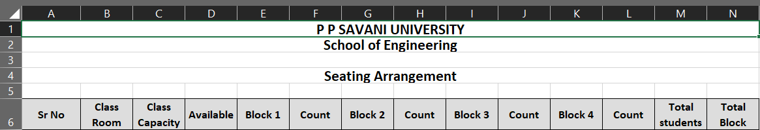
Figure 7.1: Seating Allocation Summary Report (Excel Output)

7.b Branch-wise Allocation Report (Sample Layout):
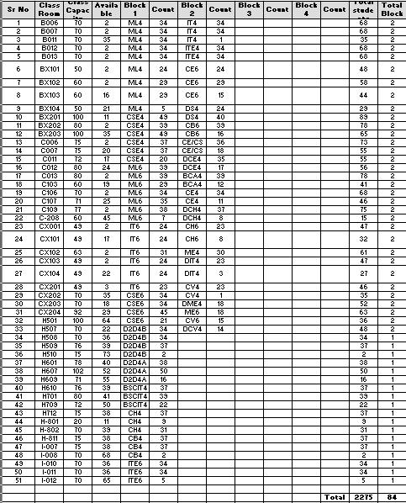
Figure 7.2: Branch-wise Allocation Report

7.c Quick Summary(Right panel):

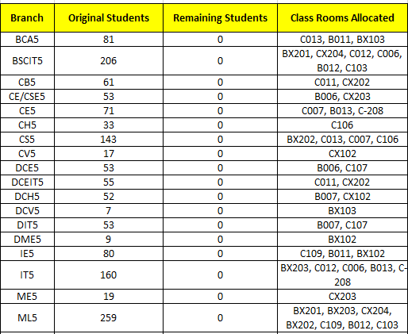
Figure 7.3: Quick Summary Panel in Output

7.d Overall Output:
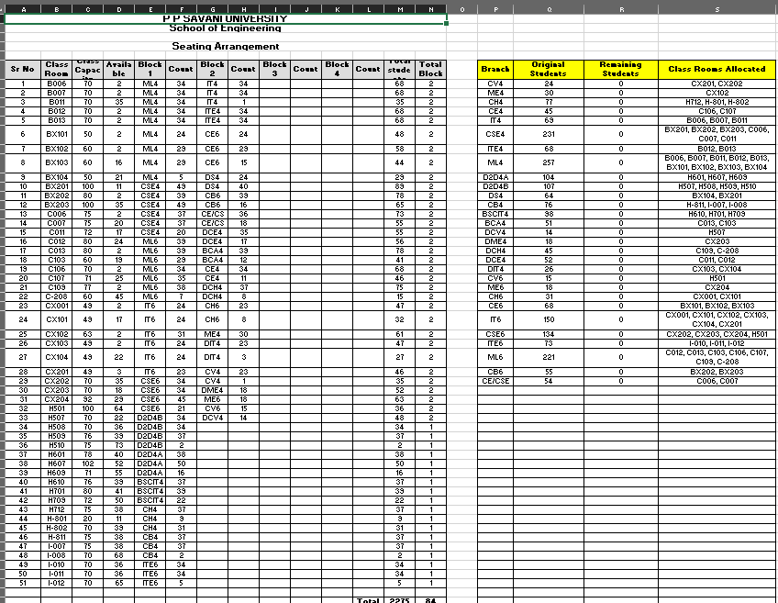
Figure 7.4: Complete Seating Arrangement Output Sheet

7.e Error:

Warning Type | Description | Suggested Action
Missing Capacity | Classroom capacity not found | Update classroom sheet
Invalid Branch Code | Unknown branch in student file | Verify student data
Remaining Students | Not all students could be placed | Increase classrooms or reduce buffer seats
Figure 7.5: Error/Warning Display Screen

8. Future Scope and Enhancements

The Smart Exam Seating Allocator has been architected with scalability and operational robustness in mind. While the current release meets core functional KPIs, several strategic enhancements can position the system for enterprise-grade adoption.

8.a Integration with Institutional ERP Systems
- Direct syncing with university ERP platforms (e.g., Oracle Campus, SAP Student Lifecycle).
- Automated fetching of student lists, department structures, and room inventories.

8.b AI-Driven Predictive Allocation
- Use of machine learning to forecast seating density based on past exam trends.
- Dynamic block creation based on real-time headcount fluctuations.

8.c Automated Invigilator Assignment
- Mapping faculty availability, department distribution, and workload balancing.
- Auto-generated invigilation schedules aligned with seating charts.

8.d Real-Time Dashboard & Analytics
- Live occupancy metrics.
- Heatmaps of classroom utilization.
- Data-driven optimization suggestions for exam controllers.

8.e Mobile-App Integration
- Students receive seating details directly on smartphone.
- Room-navigation assistance via QR codes and indoor maps.

8.f Advanced Security & Compliance
- Role-based login for exam officers, HODs, and administrators.
- Audit logs for all data uploads and modifications.

8.g Multilingual Support
- Gujarati, Hindi, and English interfaces for broader accessibility.

8.h Cloud Deployment
- Faster processing using serverless compute.
- On-demand scalability during exam seasons.

9. SYSTEM SECURITY MEASURES
The Smart Exam Seating Allocator is designed with a strong emphasis on security, reliability, and data protection. Even though the system operates without maintaining persistent storage, it incorporates multiple layers of safeguards to ensure that all user data is handled securely throughout its lifecycle. These measures collectively protect sensitive information, prevent unauthorized access, and ensure stable system performance under various conditions.

9.a Data Security
The system adopts a stateless processing architecture, which means that no user data is permanently stored on the server at any stage of operation. All uploaded files are processed temporarily in the system’s memory (RAM), and once the seating allocation output is generated, the data is immediately discarded.
This approach provides several key benefits:
- Eliminates the risk of long-term data exposure or unauthorized retrieval
- Ensures complete confidentiality of sensitive student and examination data
- Reduces storage-related vulnerabilities such as data breaches or leaks
- Aligns with institutional and regulatory data privacy standards
By avoiding persistent storage, the system significantly minimizes its attack surface and enhances overall data security.

9.b File Validation and Input Security
To maintain system integrity and prevent the processing of harmful or invalid data, strict input validation mechanisms are implemented at multiple levels. These checks ensure that only properly structured and safe files are accepted by the system.
Key validation measures include:
- Restricting uploads exclusively to supported formats such as .xlsx and .xls
- Verifying file structure through predefined column validation rules
- Detecting and rejecting corrupted, incomplete, or improperly formatted files
- Performing data sanitization to remove null values, duplicate entries, unexpected characters, and inconsistent formatting
These safeguards help ensure that only clean, accurate, and reliable data enters the processing pipeline, thereby improving both system stability and output quality.

9.c Error Handling and Exception Management
The system is equipped with robust error handling mechanisms to ensure smooth operation even when unexpected issues arise. Instead of allowing failures to disrupt the application, controlled exception handling techniques are used to manage errors effectively.
This includes:
- Implementation of try-catch blocks to capture and handle runtime exceptions
- Prevention of system crashes by gracefully terminating faulty processes
- Display of clear, user-friendly error messages instead of technical system logs
- Isolation of invalid inputs to prevent them from affecting subsequent processing stages
This structured approach ensures a seamless user experience while maintaining the integrity and reliability of the system.

9.d Access Control (Current & Future Scope)
At present, the system is designed without authentication mechanisms to prioritize simplicity, ease of use, and rapid accessibility for users. However, recognizing the importance of controlled access in real-world deployments, several enhancements are planned for future versions.
Potential improvements include:
- Implementation of a role-based access control system (e.g., Administrator, Exam Coordinator)
- Restriction of critical functionalities such as file uploads and report generation to authorized users
- Integration of secure authentication mechanisms, including session-based login systems
- Monitoring and logging of user activities for accountability and audit purposes
These enhancements will further strengthen the system’s security framework and make it suitable for deployment in larger institutional environments.

9.e Protection Against Malicious Inputs

The system incorporates multiple safeguards to defend against malicious data and potential security threats. Special care is taken to ensure that uploaded files are treated strictly as data sources and not as executable content.
Security measures include:
- Prevention of execution of embedded scripts or macros within uploaded files
- Use of trusted and secure libraries such as Pandas and OpenPyXL for safe data parsing
- Strict data interpretation rules to avoid unintended execution of code
- Protection against common vulnerabilities such as injection attacks or malformed input exploitation
These precautions ensure that the system remains secure even when handling external or user-provided data, maintaining both application safety and data integrity.

10. COST ESTIMATION OF THE PROJECT

The cost estimation for the Smart Exam Seating Allocator project is performed using a simplified yet practical approach that considers development effort, time investment, and resource utilization. Since the project is built using open-source technologies and does not require complex infrastructure, the overall cost remains significantly low while still delivering high efficiency and functionality.

10.a Estimation Method
The project cost is calculated using an Effort-Based Estimation Model, which is widely used in software engineering for small to medium-scale projects. This method determines the total cost based on:
- The number of hours required to complete each development phase
- The complexity of tasks involved in each stage
- An average hourly development rate
By multiplying the total estimated effort (in hours) by the cost per hour, a realistic approximation of the total development cost is obtained. This method is simple, transparent, and suitable for academic and prototype-level projects.

10.b Effort Distribution
The total development effort is divided into multiple phases to ensure systematic planning and execution. Each phase contributes to the successful completion of the project.
Activity | Estimated Hours
Requirement Analysis | 10 hours
System Design | 15 hours
Algorithm Development | 25 hours
UI Development | 10 hours
Testing & Debugging | 20 hours
Documentation | 15 hours
Total Effort | 95 hours
Explanation of Effort Allocation:
- Requirement Analysis: Understanding system needs, defining constraints, and identifying user requirements
- System Design: Planning architecture, workflows, and seating allocation logic
- Algorithm Development: Core logic implementation for efficient seat distribution
- UI Development: Designing a simple and user-friendly interface for file upload and output display
- Testing & Debugging: Identifying and resolving errors, ensuring accuracy and reliability
- Documentation: Preparing reports, user guides, and technical descriptions

10.c Cost Calculation
The total development cost is calculated based on the estimated effort and an assumed average hourly rate.
- Cost per hour = ₹200
- Total Effort = 95 hours
Total Cost Calculation:
Total Cost=95×200=₹19,000\text{Total Cost} = 95 \times 200 = ₹19,000Total Cost=95×200=₹19,000
This cost represents the approximate development expense if the project were to be implemented in a real-world scenario with paid resources.

10.d Tool Cost
One of the major advantages of this project is the use of open-source tools and technologies, which eliminates licensing costs entirely.
Tool / Technology | Cost
Python | Free
Django | Free
Pandas | Free
OpenPyXL | Free
Visual Studio Code | Free
Total Tool Cost | ₹0
The use of these tools not only reduces the financial burden but also provides flexibility, scalability, and strong community support.

10.e Maintenance Cost
Although the system does not require heavy infrastructure, some level of ongoing maintenance is necessary to ensure smooth operation and adaptability to future requirements.
Estimated Annual Maintenance Cost:
- Bug fixes and minor updates: ₹3,000 – ₹5,000
This includes:
- Fixing unexpected errors or edge cases
- Updating dependencies and libraries
- Improving performance and usability based on feedback

The Smart Exam Seating Allocator is a highly cost-effective solution, primarily due to its efficient design and reliance on open-source technologies. The absence of licensing fees, combined with moderate development effort, results in a low overall project cost.
Despite its affordability, the system delivers significant value by automating a complex and time-consuming process, reducing manual effort, and improving accuracy. This makes it an ideal solution for educational institutions seeking an economical yet reliable examination management tool.

Bibliography

Django Software Foundation
https://docs.djangoproject.com/
- Wes McKinney
Python for Data Analysis, O’Reilly Media
https://wesmckinney.com/book/
https://www.oreilly.com/library/view/python-for-data/9781491957653/
- OpenPyXL Developers
OpenPyXL Documentation
https://openpyxl.readthedocs.io/
- Pandas Documentation Team
Pandas Reference Guide
https://pandas.pydata.org/docs/
- Smith, J. (2020)
Algorithm Design for Resource Allocation Systems, Springer Publications
https://link.springer.com/
- ISO
ISO/IEC 9126: Software Engineering — Product Quality Standards
https://www.iso.org/standard/22749.html
- Stack Overflow & GitHub Community References
Bug resolutions and best practices
https://stackoverflow.com/
https://github.com/

Appendices

Appendix A: Sample Classroom File Format
Classroom | Capacity
C-101 | 60
C-102 | 50
C-103 | 40

Appendix B: Sample Student File Format
Branch | No. of Students
CE-A | 60
CE-B | 60
IT-A | 40
ME-A | 35

Appendix C: System Architecture Diagram
(In the report, include your architecture diagram if available.)
Appendix D: Screenshot of Web Interface
- Upload page
- File validation messages
- Download page
Appendix E: Test Case Sheets
- Unit testing sheets
- Integration testing logs
- Excel output validation sheets

Glossary

This glossary consolidates all key technical and domain-specific terms used throughout the project. It enables stakeholders, evaluators, and future developers to align on a common vocabulary and ensures seamless knowledge transfer.
Term | Definition
Seating Allocation | Automated arrangement of students into classrooms based on predefined rules.
Branch | Academic department or specialization of students.
Capacity | Maximum number of students a classroom can accommodate.
Block | Grouping of students from the same branch within a room.
ERP | Enterprise Resource Planning system used for institutional data management.
Algorithm | Logical sequence of steps executed to achieve automated allocation.
Validation | Techniques used to ensure input data correctness.
Excel Report | Final downloadable output containing seating allocation tables.
UI | User Interface used to upload files and trigger processing.
Greedy Allocation | A rule-based strategy that assigns resources step-by-step for maximum efficiency.

